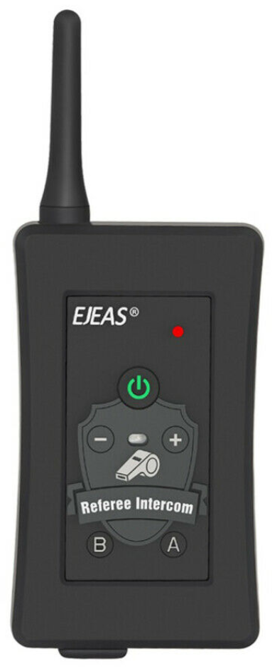

Instruction for pairing previously UNPAIRED Radios
- Power on radio by pressing GREEN Power On button for approx. 2 secs. Release Power On button when light flashes RED. Once released light should start flashing BLUE.
- To erase pairing settings from any previous radios press both – & + together until light briefly flashes RED before returning to BLUE.
- Agree with colleague which radios will be A (referred to as Radio 1) and B (referred to as Radio 2).
- On Radio 1 press & hold A until light flashes RED & BLUE.
- On Radio 2 press & hold B until light flashes RED & BLUE.
- Both radios should now be flashing RED & BLUE.
- On Radio 1 press A briefly (light should now be flashing BLUE). The radios should now pair in approx. 3-5 secs. This is indicated by lights on both radios flashing BLUE and in sync.
- On Radio 1 press A again to start Intercom mode (this may take up 10 seconds).
- When the radios are actively transmitting and receiving Radio 1 should be flashing RED while Radio 2 should still be flashing BLUE.
- To Power Off press the RED dot & A simultaneously.

(The most common problems are that you don’t press the A button briefly for the 2nd time to pair them, or you wait for the intercom mode without pressing A for the 3rd time).

If you wish to use a 3rd party headset and microphone rather than the one supplied it must FIRST be attached to the WHITE Adaptor Cable before being plugged into the radio.

Instructions for previously PAIRED Radios
If you have been paired with the same colleague and you have not paired your radios with ANY others between games you can follow these steps for setup:
- Power on the radio by pressing the GREEN Power ON button for 2 seconds. First the light comes on RED then release Power On button when light flashes BLUE.
- On Radio 1 press the A button to start the Intercom mode (this may take up to 10 seconds).
- When they are actively transmitting and receiving Radio 1 should be flashing RED while Radio 2 should still be flashing BLUE.
- To Power Off press the RED dot & A simultaneously.

Battery Charging
Use the supplied cable for charging. Radio will charge from any standard USB supply.

Battery Low Warning
Battery Life is 8 hours. If beeping repeatedly you have about 15 minutes usage left before radio abruptly shuts itself down.

